Europe by Rail

Prerequisites, Goals, and Outcomes
Prerequisites: Students should have mastered the following prerequisite skills.
- Graphs - Knowledge of graph representation, particularly adjacency lists
- Graph Algorithms - Knowledge of Dijkstra's shortest path algorithm
Goals: This assignment is designed to reinforce the student's understanding of the implementation of a fundamental graph algorithm
Outcomes: Students successfully completing this assignment would master the following outcomes.
- Understand graph representation
- Understand how to implement Dijkstra's shortest path algorithm

Background
Traveling through Europe by rail is a cheap and effective way to experience the sights, sounds, and culture of a wide array of countries and cities. Generally, travelers purchase rail passes that allow unlimited travel on the rail system. Individual tickets, however, can be purchased.

Description
The program for this assessment calculates the cheapest route between two cities in a mock European rail system. The graph that represents the rail system is pictured below.
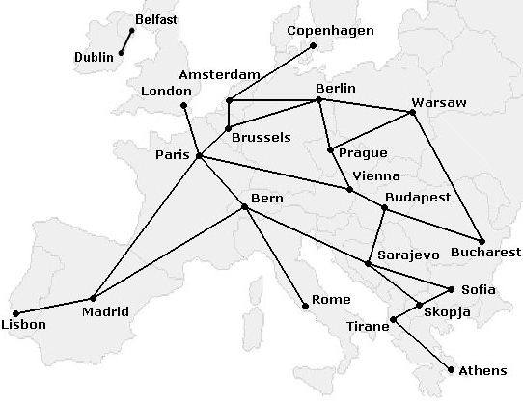
Figure 1 A mock European rail system
In this program, a weighted graph is constructed to represent rail services to and from European cities. Each service from a city has an associated destination city, a fee (in Euros), and a distance (in kilometers). The program processes user input of a source city and a destination city. The program then displays the cheapest route from the source city to the destination city. In addition, for each route, the total cost and total distance are displayed. The file services.txt contains the data for the available services.

Classes
This program utilizes three main classes, class City, class Service, and class RailSystem. The implementations for class City and class Service are given. Class City maintains information about a city. Class Service models a rail service from the rail system. This class contains public data members for a destination city, a fee, and a distance. Both of these classes are used by class RailSystem.
Class RailSystem models the rail system using an adjacency list representation. These adjacency lists are represented using the STL class map. Specifically, a map of type string to type list<Service*> represents the rail system. The following image represents how a portion of the rail system is represented. Note that the ticket fees and distances are left out to simplify the picture.
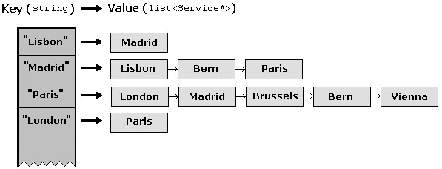
Figure 2 Adjacency list representation of the rail system
Essentially, in the above representation, a linked list of outgoing services can be indexed using a string containing the source city name. For example, notice in the above picture, Madrid has three outgoing services: one to Lisbon, one to Bern, and one to Paris. This matches the picture of the rail system at the top of this handout. In addition to this type of map object, another type of map is used to map city names to pointers to their respective City objects. This map object is used in the search algorithm.
Sample output from this program is shown in the figure below.
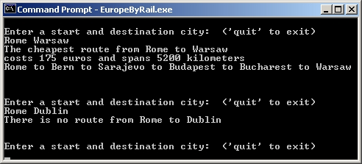
Figure 3 Output from a sample solution
The algorithm to be used is a positive-weighted, shortest path algorithm. Each City is a node in a graph, and each Service is an edge. Edges have an associated cost: the fee for the ticket. The goal is to find the cheapest route from the source city to the destination city.
To perform a new search, a pointer to a City object representing the start city should be added to an initially empty candidates queue. The algorithm continues by exploring the services of each candidate city, possibly adding new candidates to the list. The algorithm labels each City object with a number representing the cost of the cheapest route to it from the origin found so far. This is stored in member total_fee of class City. This value may decrease as new routes that are cheaper are found, but the value never increases.
To recover the actual path found by the search, every City object contains a string from_city. This string will be updated by the search algorithm to contain the name of the city by which it was reached through the cheapest path. In other words, if examining Brussels reveals a cheaper path to Paris, update variable total_fee of the City object that corresponds to Paris, and set its from_city equal to "Brussels". Once the search is complete, the cheapest route to the destination has been found, and the from_city strings can be traversed from the destination to the origin to reconstruct the path.

Files
Following is a list of files needed to complete this assessment.
- handout-files.zip contains all of the following necessary files:
  - main.cpp - This file contains the main routine.
  - City.h - This defines class City.
  - Service.h - This defines class Service.
  - RailSystem.h - This declares a class to represent the rail system.
  - RailSystem.cpp - This is a partial implementation of class RailSystem.
  - services.txt - This file contains data that defines the rail system services.

Tasks
To complete this assessment, you need to complete the implementation of class RailSystem.
To begin, verify the files needed for this assessment.
- Extract the archive to retrieve the files needed to complete this assessment.
Following is an ordered list of steps that serves as a guide to completing this assessment. Work and test incrementally. Save often.
- Begin by examining the implementation of class City and Service.
- Next, complete function load_services of class RailSystem. The data file of services is services.txt. Function load_services() must correctly build populate the cities and outgoing_services maps.
- Then, finish the implementation of function RailSystem::reset. This function should iterate through the cities map and reset the data members of the City objects.
- Next, complete the RailSystem destructor implementation. The destructor should ensure that all City and Service objects allocated using new are deallocated using delete.
- Then, complete the definition of function calc_route(). This function accepts the names of start and destination cities, uses a positive-weighted shortest path algorithm, and returns a pair<int, int> object with the total fee and total distance from the start city to the destination city. If there is not a path from the start city to the destination city, the function returns the pair(INT_MAX, INT_MAX).
- Finally, implement function recover_route(). Function recover_route() accepts the name of a destination city as an argument, and returns a string which contains, in order, the city names from the source city from which the destination city was reached through the destination city. The path can be recovered through the from_city strings, which should have been set by function calc_route(). The city names must be separated by the four-character string " to ". See the screen shot of sample output above for samples of strings created by function recover_route().

Submission
Submit only the following.
- RailSystem.cpp - finished implementation of class RailSystem

Go to top of question.

